WARNING: RIR TEST database clear every day.

Note: set all values the same as in the examples except:IPv4 network, Ipv6 network, nic-hdl, mn**t-email**

Preparation for rir swip functional tests:

1 Create maintainer and person objects

Open link <https://apps.db.ripe.net/startup/>

* 1. Select database – RIPE Test Database
  2. Fill person objects and maintainer object:

Note: please set real email.

Person: Automation Infoblox

NIC hdl: - AI1-TEST

Address: BY Minsk Radialnya str 36

Phone: +375111111111

Email: hvashchilo@infoblox.com

mntner: qaautomationinfoblox  
Password: password

As result should be created two objects (Please see screen shot ripe1):

mntner: qaautomationinfoblox  
descr: Maintainer  
admin-c: [AI1-TEST](http://apps.db.ripe.net/whois/lookup/test/person-role/AI1-TEST.html)

upd-to: hvashchilo@infoblox.com  
auth: MD5-PW #Filtered  
mnt-by: [qaautomationinfoblox](http://apps.db.ripe.net/whois/lookup/test/mntner/qaautomationinfoblox.html)

referral-by: [qaautomationinfoblox](http://apps.db.ripe.net/whois/lookup/test/mntner/qaautomationinfoblox.html)

notify: amakayed@infoblox.com  
changed: amakayed@infoblox.com 20121210  
remarks: Accepted the RIPE Database Terms and Conditions  
source: TEST #Filtered

person: Automation Infoblox  
address: By Minsk Radialnya str 36  
phone: +375111111111  
e-mail: hvashchilo@infoblox.com  
nic-hdl: AI1-TEST  
mnt-by: [qaautomationinfoblox](http://apps.db.ripe.net/whois/lookup/test/mntner/qaautomationinfoblox.html)

changed: hvashchilo@infoblox.com 20121210

source: TEST

You can check them here: <https://apps.db.ripe.net/search/query.html>

Ripe1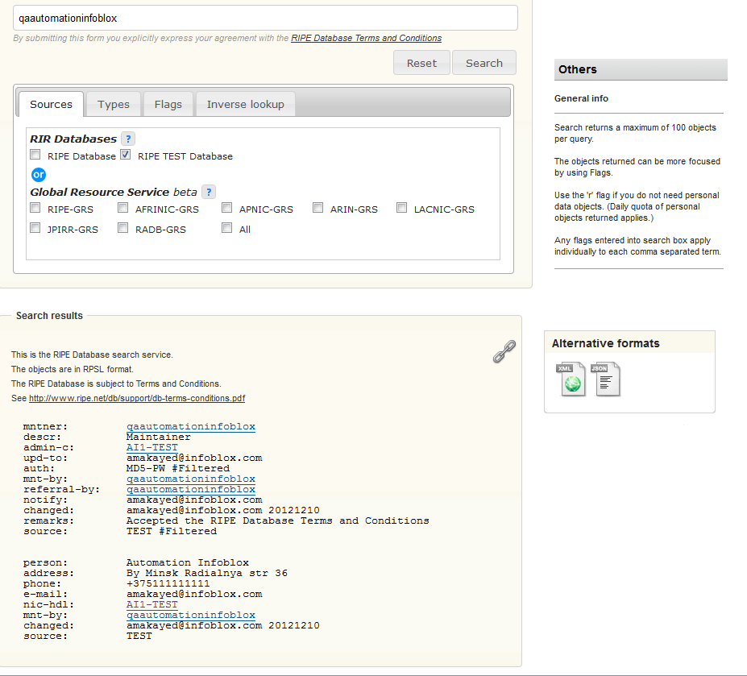

1. Create RIR Organisation (organisation object)
   1. Select: Update/Create an object.
   2. Select. Object type: organisation. Source Database: RIPE TEST Database.
   3. Click “Create”.
   4. Fill opened form. Please see screenshot Ripe2.
   5. Add maintainer password and low low level maintainer(TEST-DBM-MNT) password(Password is "emptypassword" without the quotes.) to session passwords. Please see screenshot Ripe2.

Note: changed attribute value contains mail: [amakayed@infoblox.com](mailto:amakayed@infoblox.com) + data when object changed: 20121210

As result should be created object:

organisation: ORG-TA1-TEST  
org-name: test_infoblox_automation  
org-type: OTHER  
address: By Minsk Radialnya str 36  
e-mail: hvashchilo@infoblox.com  
mnt-ref: [qaautomationinfoblox](http://apps.db.ripe.net/whois/lookup/test/mntner/qaautomationinfoblox.html)

mnt-by: [qaautomationinfoblox](http://apps.db.ripe.net/whois/lookup/test/mntner/qaautomationinfoblox.html)

changed: hvashchilo@infoblox.com 20121210  
source: TEST

Ripe2

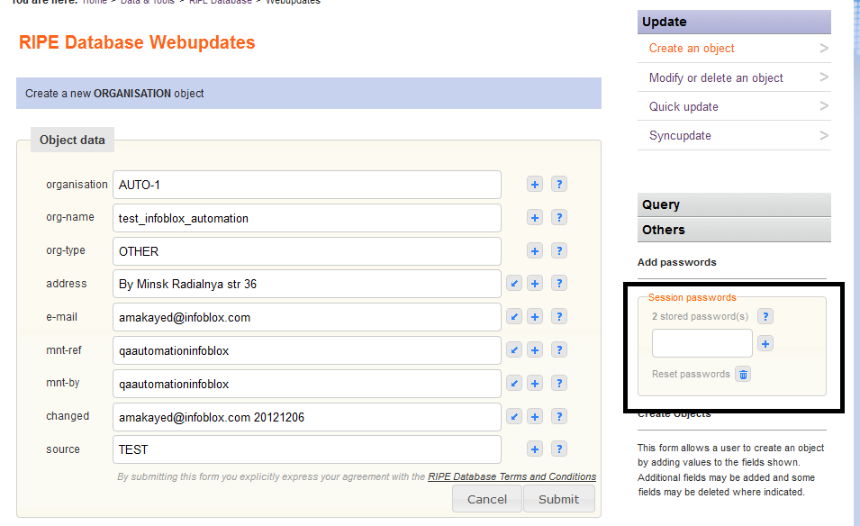

1. Create inetnum/inet6num object

Adding/modifying/deleting operations for networks in ripe database using NIOS allowed only for networks in network container. Container root network should be created in nios as rir network and the same object(inetnum/inet6num) should be cteated in ripe database manualy.

* 1. Select: Update/Create an object.
  2. Select. Object type: inetnum. Source Database: RIPE TEST Database.
  3. Click “Create”.

Notes:

1. mainteiner and low level mainteiner passwords should be saved in session password
2. Created network should have mask 24. For example: 17.3.0.0 - 17.3.0.255
3. Add org parameter and set created earlier RIR Organization

Fill wizard: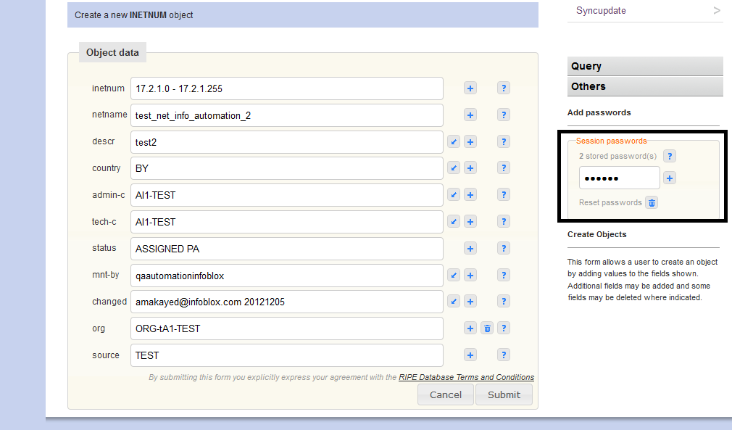

Created object

inetnum: 17.3.0.0 - 17.3.0.255  
netname: test_net_info_automation_2  
descr: test2  
country: BY  
admin-c: AI1-TEST

tech-c: AI1-TEST

status: ASSIGNED PA  
mnt-by: [qaautomationinfoblox](http://apps.db.ripe.net/whois/lookup/test/mntner/qaautomationinfoblox.html)

changed: hvashchilo@infoblox.com 20121210  
source: TEST

Create inet6num

* 1. Select: Update/Create an object.
  2. Select. Object type: inet6num. Source Database: RIPE TEST Database.
  3. Click “Create”.

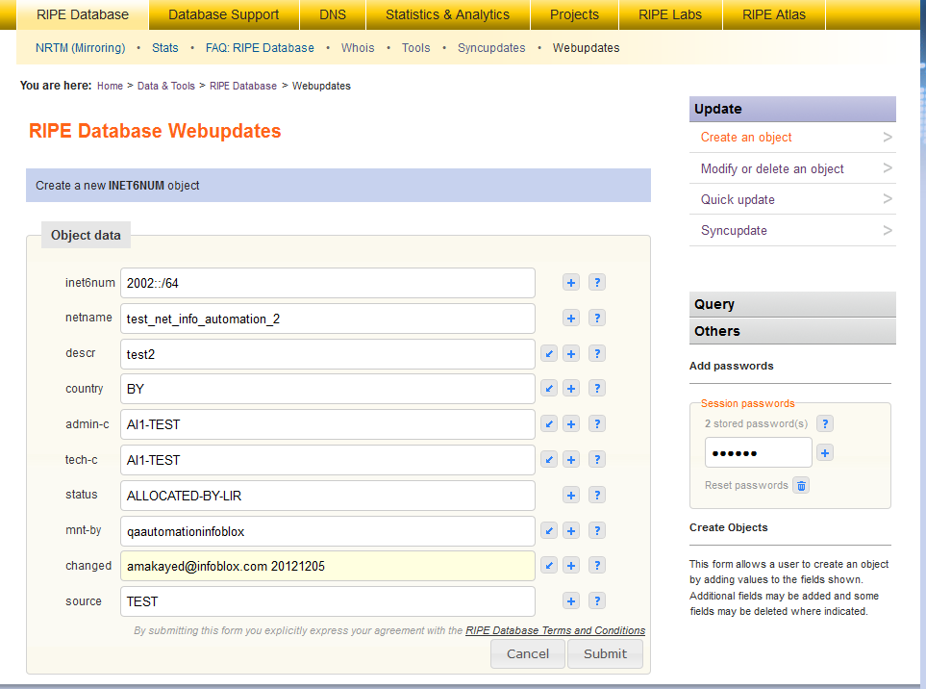

inet6num: 2002::/64  
netname: test_net_info_automation_2  
descr: test2  
country: BY  
admin-c: [AI1-TEST](http://apps.db.ripe.net/whois/lookup/test/person-role/AI1-TEST.html)

tech-c: [AI1-TEST](http://apps.db.ripe.net/whois/lookup/test/person-role/AI1-TEST.html)

status: ALLOCATED-BY-LIR  
mnt-by: [qaautomationinfoblox](http://apps.db.ripe.net/whois/lookup/test/mntner/qaautomationinfoblox.html)

changed: hvashchilo@infoblox.com 20121205  
source: TEST

1. Open test-data/script/rir-startup.properties files and set required parameters (parameters should be the same as in objects in rir test database).

Properties:

**organization-id=ORG-tA1-TEST** – organization ID(created in step 2)

**root-network=17.3.0.0/24** – ipv4 network container

**root-network_ipv6=2002::/64** – ipv6 network container

**mnt-email=** **hvashchilo@infoblox.com** – please set real mail address because ripe test database will send mail notification if adding data is incorrect.

**nic-hdl=AI1-TEST** – created person identifier, this value automatically created by ripe test database.

**ipv4_mask_shift=5** – shift of container mask for creating sub networks (For example if container mask 24 shift 5 sub networks have mask 28). Please set shift for mask which allow to create at least 3 sub networks

**ipv6_subnet_prefix=68** –ipv6 subnets prefix. Please set prefix which allow creating at least 3 subnets of root ipv6 network.

5 Open NIOS (This and all next steps have automated)

5.1 Go to Grid tab and open “Grid properties editor”

5.2 Go to General/Advanced tab. Select “Enable Updates Of RIR Registrations”

5.3 Go to DNS Resolver tab. Enable dns resolver and add dns resolvers: 10.0.2.35; 10.0.2.60

5.4 Click save and close.

3.5 Go to Administration/RIR Organizations tab and create RIR Organization with the same parameters as created early organization in ripe database. Please see screenshot rir_organization.

rir_organization

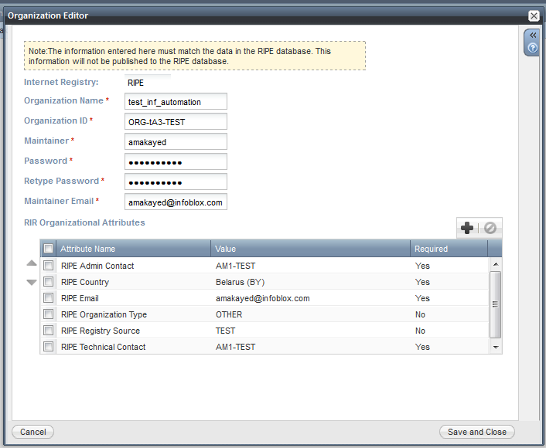

Go to IPAM tab. Create the rir network(assign it to created early rir organization) with the same parameters(rir network parameters, rir extensible attributes) as created early inetnum object. Registration Action(It’s rir network parameter) for this network should be “None”. Created network it’s roor element for network container. Now possible create (modify or delete) rir network in this container and appropriated objects will be created in ripe database.